**Case Study 10: Movie Ticket Booking System**

**Task 1**: Movie Ticket Booking System is Web based system.

**Task 2: Requirements**

- Customer account, name, email, address, phone

- Movie name, date, time

- Seat no, seat price

- Payment

- Staff's name, email, address, phone

**Task 3: Functional Lists**

**Functional requirements**

**1. Registration -**

If a customer wants to book the ticket then he/she must be registered, an unregistered user can’t book the ticket.

**2. Login -**

Customer logins to the system by entering valid user id and password for booking the ticket.

**3. Search Movie -**

The system shall have a search function. Customer or visitor can search movies based on movie name, date, time and venue

**4. Seat Viewing -**

The customer shall be shown a 2D image of the seats from which the desired seats are selected.

**5. Ticket canceling -**

The customer shall be given an option to cancel ticket one hour before the movie with some fine.

**6. Payment -**

For the customer there are many types of secure billing will be prepaid by debit or credit card.

**7. Logout -**

After the payment or browse the movie, the customer will log out.

**8. Generate ticket -**

After booking, the system can generate the portable document file (.pdf) and then sent one copy to the customer’s Email-address and another one as an SMS to customer's phone.

**9. Add movies -**

The system shall have a feature for admin to add movies and their details.

**10. Remove movies -**

The system shall have a feature for admin to remove movies.

**Non-functional requirements**

- The system must automatically log out all customers after a period of inactivity.

- The system’s back-end servers shall only be accessible to authenticated administrators.

- Sensitive data will be encrypted before being sent over insecure connections like the internet.

- The system provides storage of all databases on redundant computers with automatic switchover.

- The system should be available at all times, meaning the user can access it using a web browser.

- In case of a hardware failure or database corruption, backups of the database should be retrieved from the server and saved by the administrator.

- An end-user is using this system on any OS; either it is Windows or Linux.

- The system shall run on PC, Laptops, and PDA etc.

- The system will be a web-based application it is going to be accessible on the web browser.

- We will take a backup in our system database. In order to enable the administrator and the user to access the data from our system.

**Task 4: Use Case Diagram**

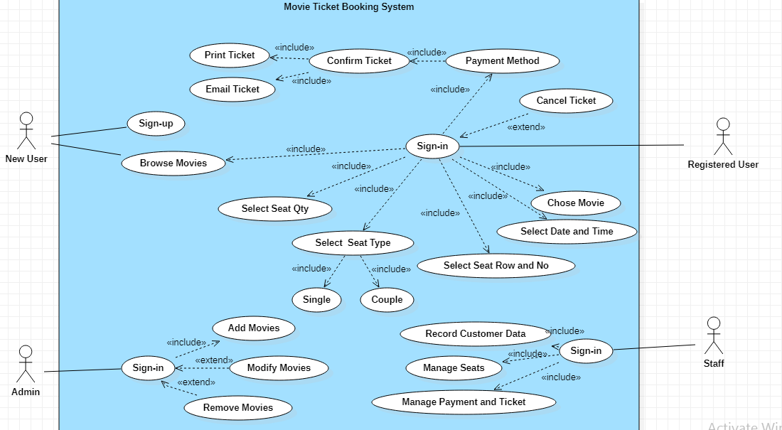

**Task 5: Database Design**

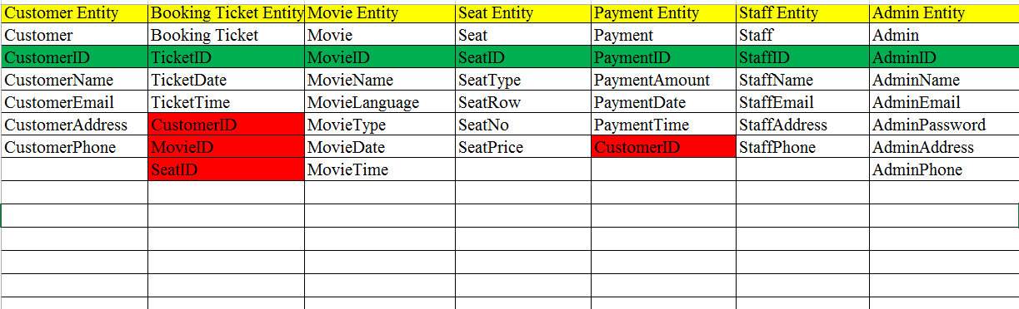

**Task 6: ERD Design**

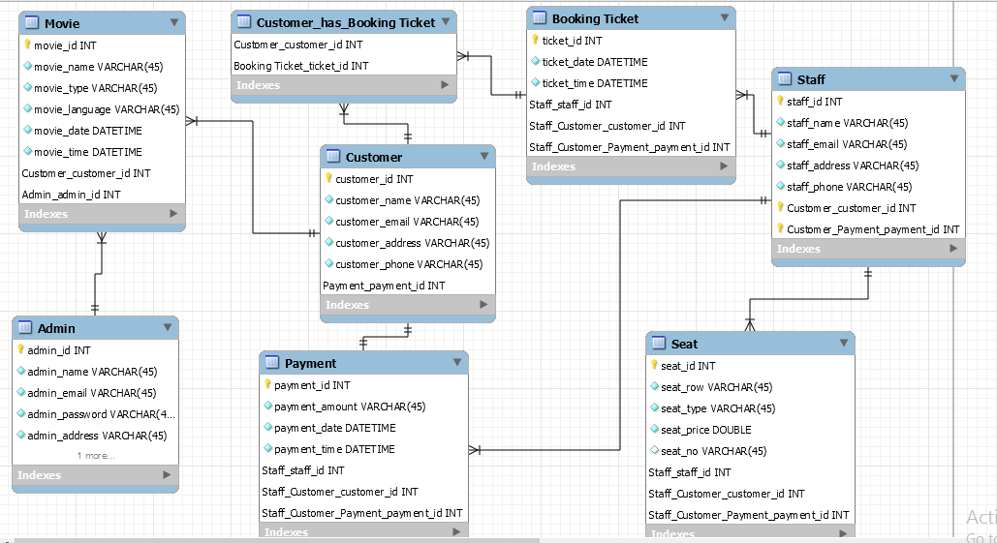

**Task 7: User Interface Design**

**User View**

Registration Form

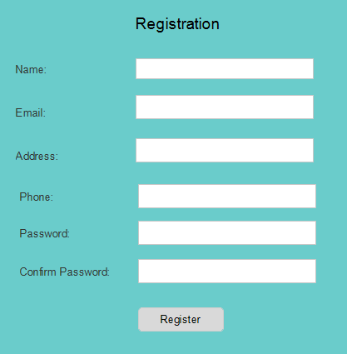

Login Form

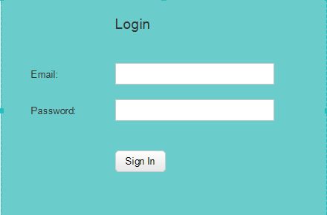

Movie Lists

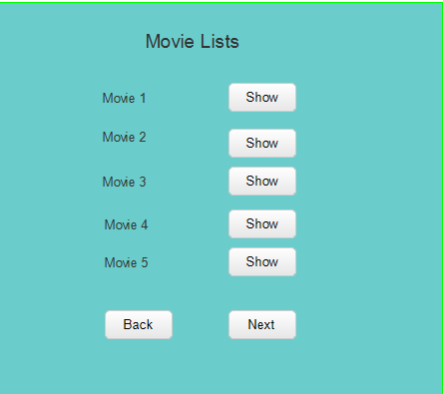

Movie Details

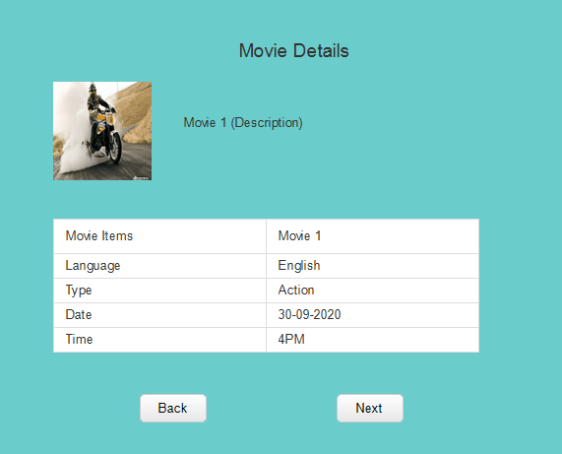

Seat and Payment

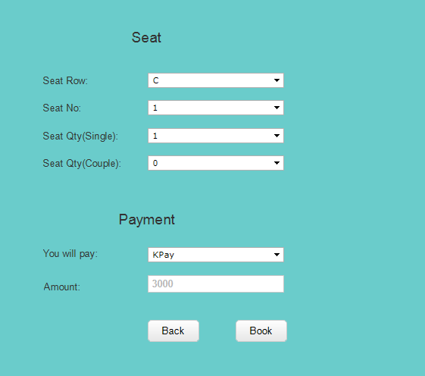

Booking Ticket

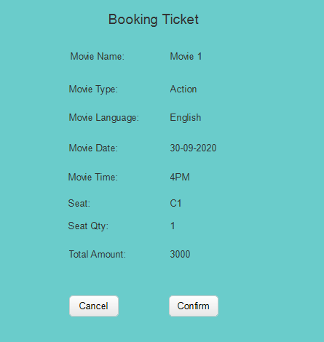

**Admin View**

Login Form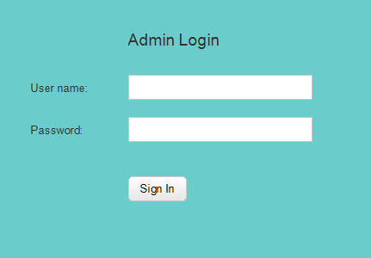

Manage Movie

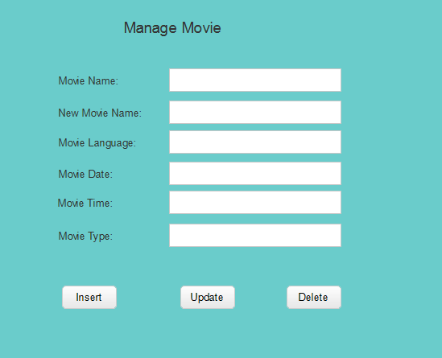

Customer Booking Details

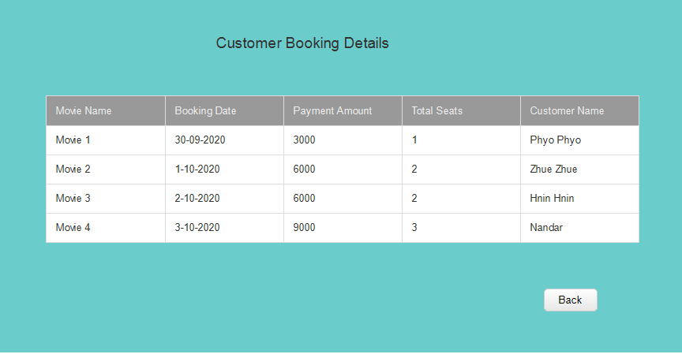

**Task 8: Class Diagram**

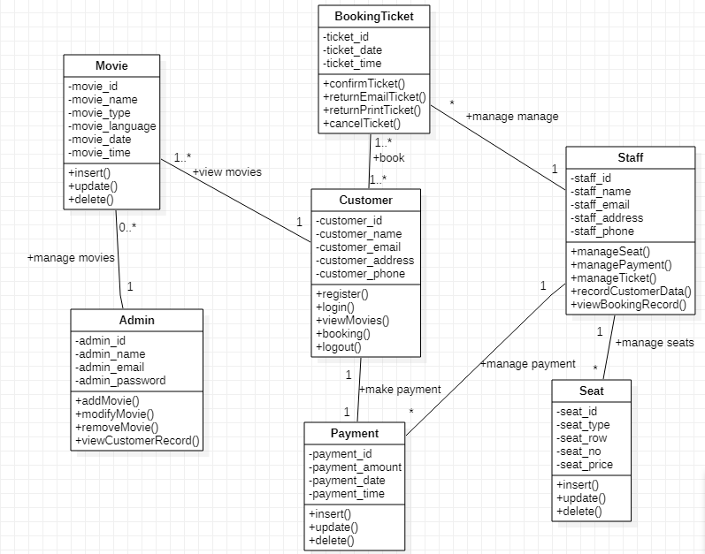

**Task 9: Test Case and Test Plan**

Test 1

* Test Plan : Registration form
* Test Data: Users need to click sign up for registration.
* Test Function: System will register the users.

Test 2

* Test Plan: Login Form
* Test Data: Users need to click Login form for entering the system.
* Test Function: It will redirect to login form.

Test 3

* Test Plan: Movie Lists Form
* Test Data: Users can click movie lists for viewing movies.
* Test Function: System will show movie lists form.

Test 4

* Test Plan: Movie Details
* Test Data: Users can click show button in movie lists form for viewing movie details.
* Test Function: It will redirect to movie details form.

Test 5

* Test Plan: Seat and Payment
* Test Data: Users can click seat and payment form for selecting seat row, no, type and qty.
* Test Function: It will redirect to seat and payment form.

Test 6

* Test Plan: Booking Ticket
* Test Data: Users need to book for booking ticket details as selected by the users.
* Test Function: It will redirect to booking ticket form.

Test 7

* Test Plan: Manage Movie
* Test Data: Admin can click insert, update and delete button for manage movies.
* Test Function: It will redirect to manage movie form.

Test 8

* Test Plan: Customer Booking Details
* Test Data: Admin need to click booking details for viewing customer booking details.
* Test Function: It will redirect to customer booking details form.

**Task 10: Application Architecture**



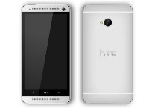

Application Tier

Data Tier

Presentation Tier